Case Study
Hospital Management System
Alishba Azhar: 000925324
Thomas Coons: 000317961
Pouya Tayyari: 000949516
Khushal Parimal Valand: 000922744
Mohawk College
COMP-CO835-09: Object Oriented Systems
Dr. Stanley Ukah
December 4th, 2024

Introduction:
The Hospital Management System is designed to deal with operational tasks within a healthcare facility. The system contains various functional areas, including patient management, household information tracking, payment and invoicing, insurance claims, staff management, and more. The goal of this system is to have smooth and efficient operation across all departments. This Hospital Management System will improve communication between departments. This case study outlines the functional requirements, use cases, and showcases various diagrams explaining the process behind how communication will work.

1. Functional Requirements:
- The functional requirements for the Hospital Management System consist of the following:
  - Maintain Patient Information:
The system must allow the receptionists and business managers to track all necessary information regarding patient information. This involves creating, reading, and updating patient information when necessary. Information such as name, date of birth, gender, and number of visits will be tracked.
  - Maintain Household Information:
The system must be able to create, read, and update household management information. The system must allow the receptionists and business managers to track information such as name, address, and telephone number, and all necessary insurance information.
  - Enter Payment Information:
The system must allow business managers to enter payment and invoice information accurately when it is received via a patient or insurance company.
  - Generate Invoices:
The system must be able to track and generate invoices for patients and insurance companies. These invoices will include the procedure involved, the patient copay amount, and the total due.
  - Send Invoice to Head of Household:
The system will allow business managers to send invoices to the head of a household at a monthly interval.
  - Send Invoices to Insurance Companies:
The system will allow business managers to send invoices to insurance companies at a weekly interval.
  - Track Overdue Payments and Insurance Claims:
The system will allow the business manager to track overdue payments and print out a report of all households that are behind on payments as well as insurance claims that were successful or denied.
  - Record Details for Patient Procedures:
The system must be able to keep track of patient and staff details when patients are meeting with hospital staff. This information should include what staff were involved with the visit, the patient’s name, the staff member's names, the reason for the procedure / visit, and all necessary insurance information regarding the specific visit associated with the patient involved.
  - Track Employee and Staff Information:
The system will allow the administrators to keep track of hospital staff. This information will include names, addresses, and telephone numbers. This will involve creating, reading, updating, and deleting staff information when necessary.

  - Record Doctor Specific Documentation:
The system must allow for doctors to record, update, and maintain information about patients regarding specific procedures that the doctors were involved in. Doctors will also be able to view the list of procedures they performed during a single week or month. The receptionists will have access to these reports so they can provide the doctors with a report regarding this information.

- Ten use cases from the system using user goal technique:
User | User goal and resulting use case
Receptionist, Business Manager | - View patient details  - Record patient details
Receptionist, Business Manager | - View household details  - Record household details
Business Manager | - Enter payment information for specific visits and procedures  - Record payment amount, payment code, and who made the payment (Insurance or Patient).
Business Manager | - Generate invoice reports  - View invoice reports
Business Manager | - Send invoice reports to household
Business Manager | - Send invoice reports to insurance companies
Business Manager | - Monitor overdue payments  - Print reports of successful or denied insurance claims.
Doctor, Nurse, Personal Support Worker | - Record details of the procedures performed into the system  - Save information to the patient’s record for future reference
Administrator | - Manage hospital staff information  - Create, update, or delete hospital staff information
Doctor | - Record details of procedure into the system  - View list of past procedures either weekly or monthly

- Six use cases from the system using event decomposition technique:
Use Case | Type of Event | Trigger | System Response
Record Household Information | External | Receptionist or Business Manager enters or updates household information | The system records or updates the household information as necessary.
Enter Payment Information | External | A patient or insurance company makes a payment. | The receptionist or business manager records the payment information, including the amount received, the patient's co-payment, and any insurance payments or denials.
Send Invoice to Head of Household | Temporal | The system internally tracks monthly intervals of invoices for households. | The system generates and sends invoices to the heads of households and allows business managers to review information before sending.
Send Invoices to Insurance Companies | Temporal | The system internally tracks weekly intervals of invoices for insurance companies | The system generates and sends invoices to insurance companies and allows business managers to review information before sending.
Generate Overdue Payments and Insurance Claims Report | External | Business manager triggers the event when they need to track overdue payments and review insurance claims | The system will generate a report when trigger occurs.
Record Doctor’s Procedure Documentation | External | Doctor updates or records specific patient procedure details they were involved in. | System records and updates patient information. The system will allow new information to be viewed as a report.

- User story showing the business manager generating a monthly invoice for a patient or household:

As a business manager, I want to generate invoices for patients or household,
so that I can accurately bill and send out invoices.

2. Use case diagrams showing a complete and comprehensive view of the entire system
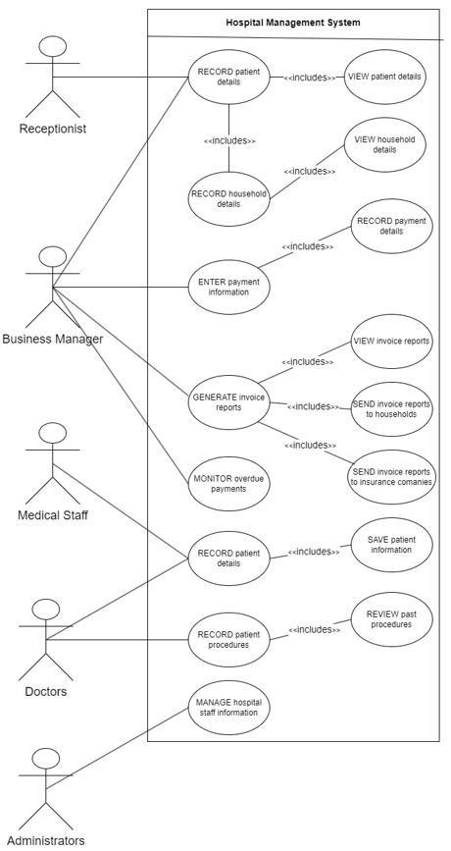
3. Two comprehensive Use Case descriptions
Use Case 1: Record Household Information
Name | Record Household Information
Actors | Receptionist, Business manager
Description | The receptionist or business manager records household details into the system, including the name, address, telephones, and insurance information.
Preconditions | Household head provides all necessary details.
Postconditions | Household information is stored or updated in system.
Triggering | New patient household or change in household details.
Main Flow of Events | - Receptionist logs into the system.  - Selects "Household Information" from the menu.  - Inputs or updates household details.  - System saves the information and displays confirmation.
Exception Handling | If information is incomplete, the system prompts the user to enter missing fields.

Use Case 2: Generate Invoices Reports
Name | Generate Invoices
Actors | Business Manager
Description | The business manager generates invoices for households and insurance companies based on hospital visits and procedures performed.
Preconditions | All visits and procedures are recorded in the system
Postconditions | Invoice are generated, saved, and ready for review or dispatch
Triggering | Monthly or weekly billing cycle reaches its interval
Main Flow of Events | - Business Manager logs into the system.  - Selects "Generate Invoices" from the menu.  - System retrieves visit and procedure data.  - System generates invoices for households and insurance companies.  - Manager reviews and sends invoices.
Exception Handling | Missing payment data: The system flags and lists visits requiring further review.

4. Two Activity diagrams for any two use cases associated with the procedures
performed by doctors in the system
Doctor Reviewing Patient Procedures:
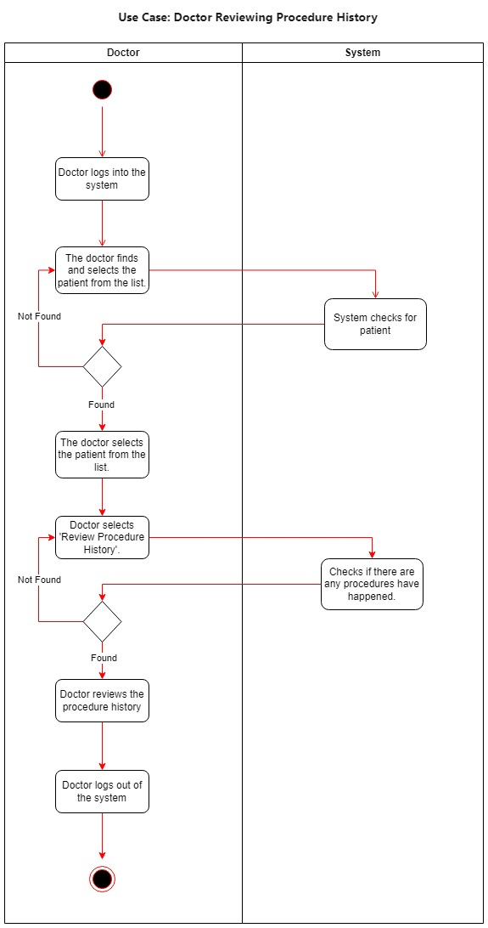
Doctor Recording Patient Procedure:
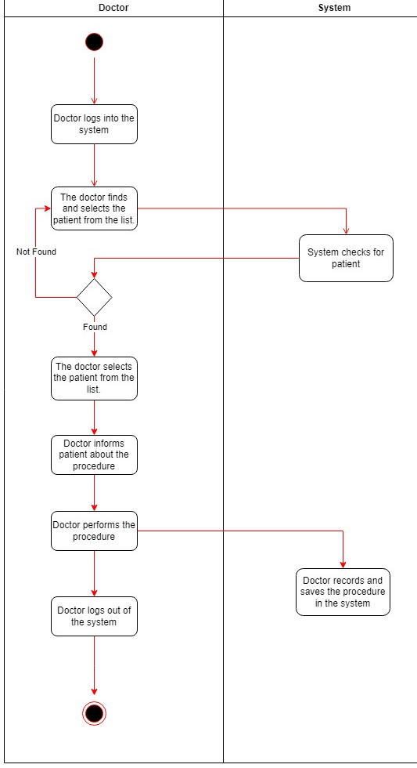

5. Sequence diagrams associated with the Use Case descriptions above:
Doctor reviewing patient records:
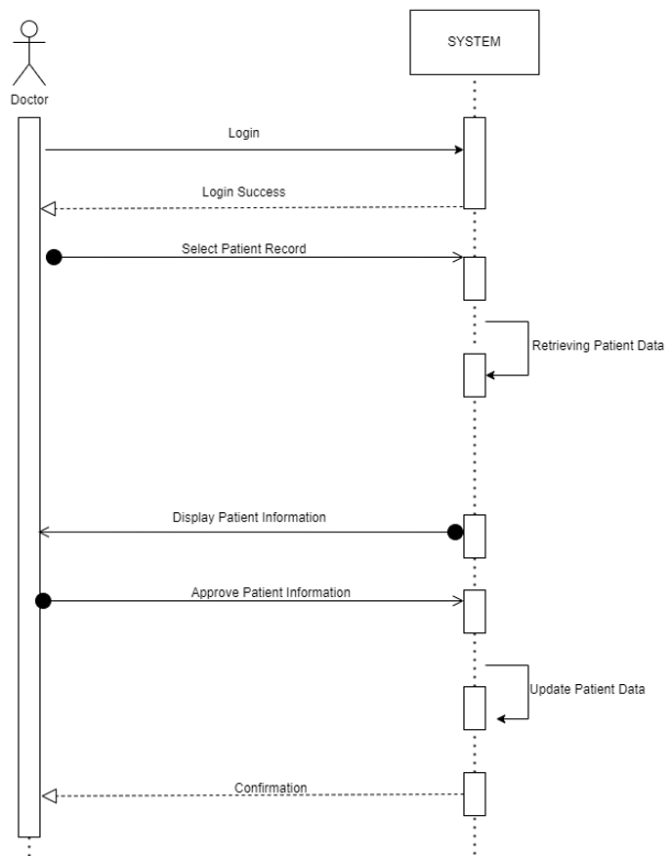
Doctor recording patient records:
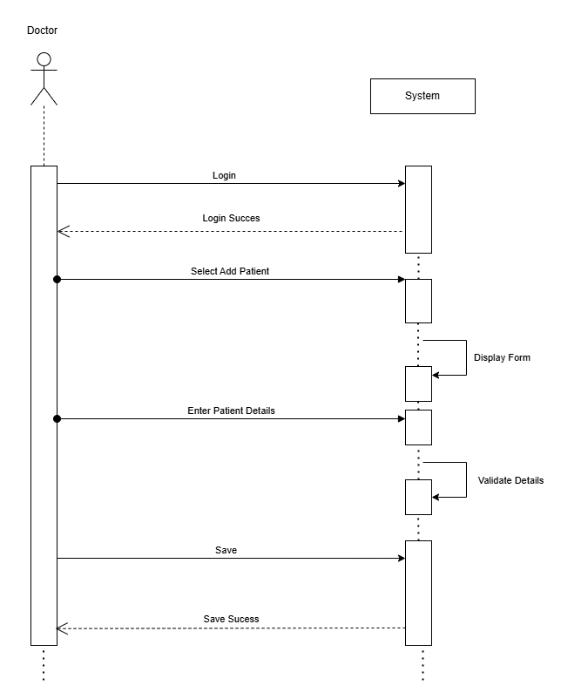

6. State diagrams associated with each of the Use Case description:
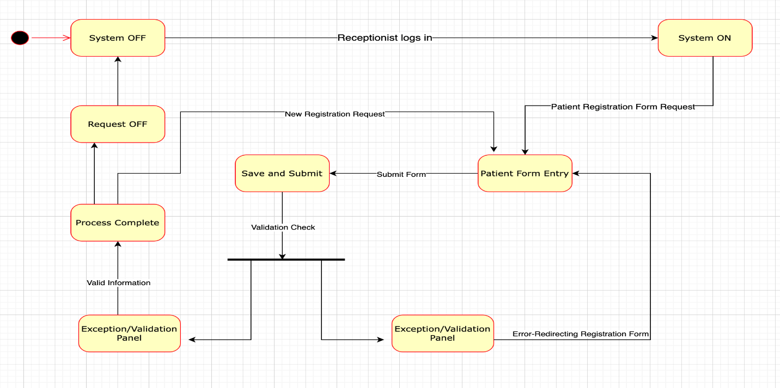

7. User Interface Design (UI/UX)
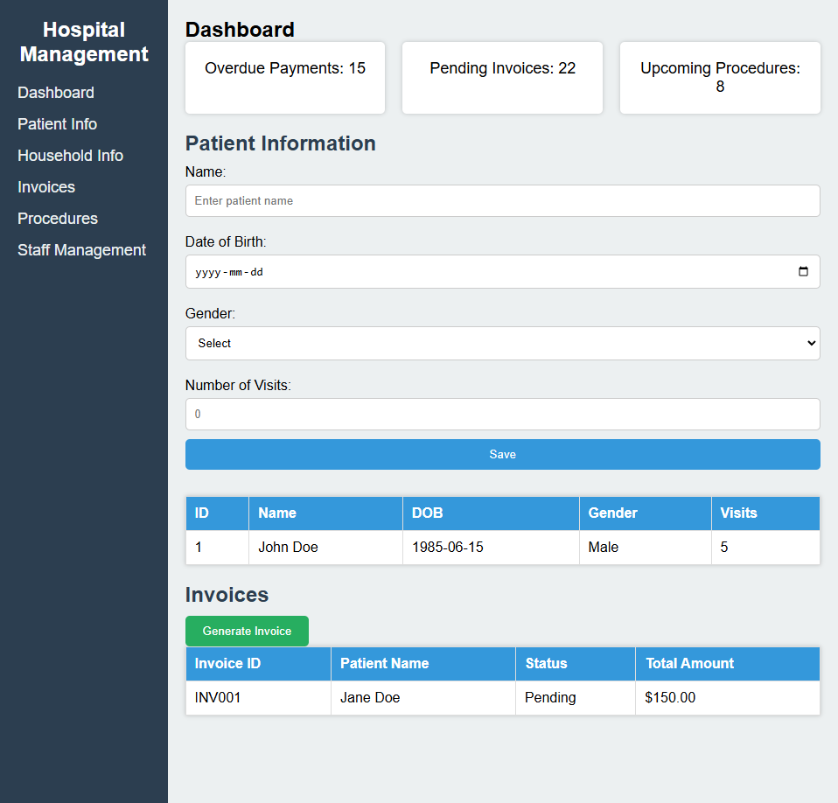

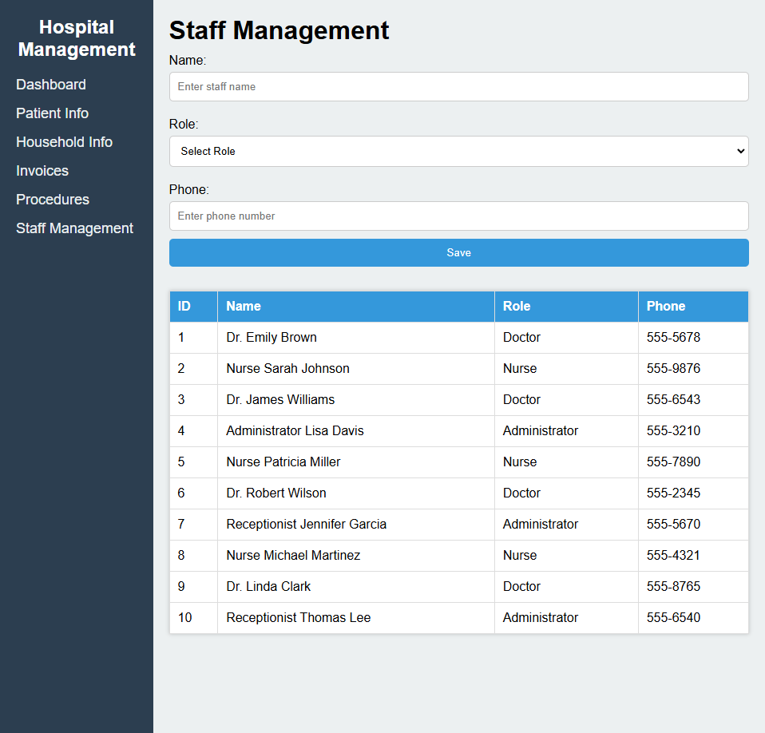
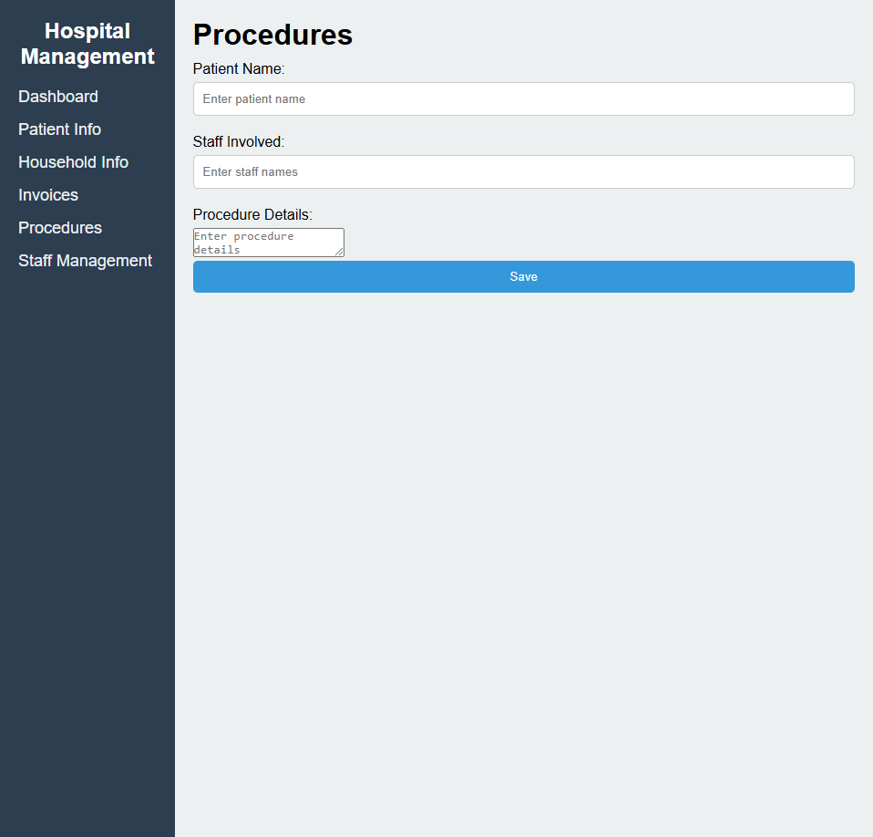
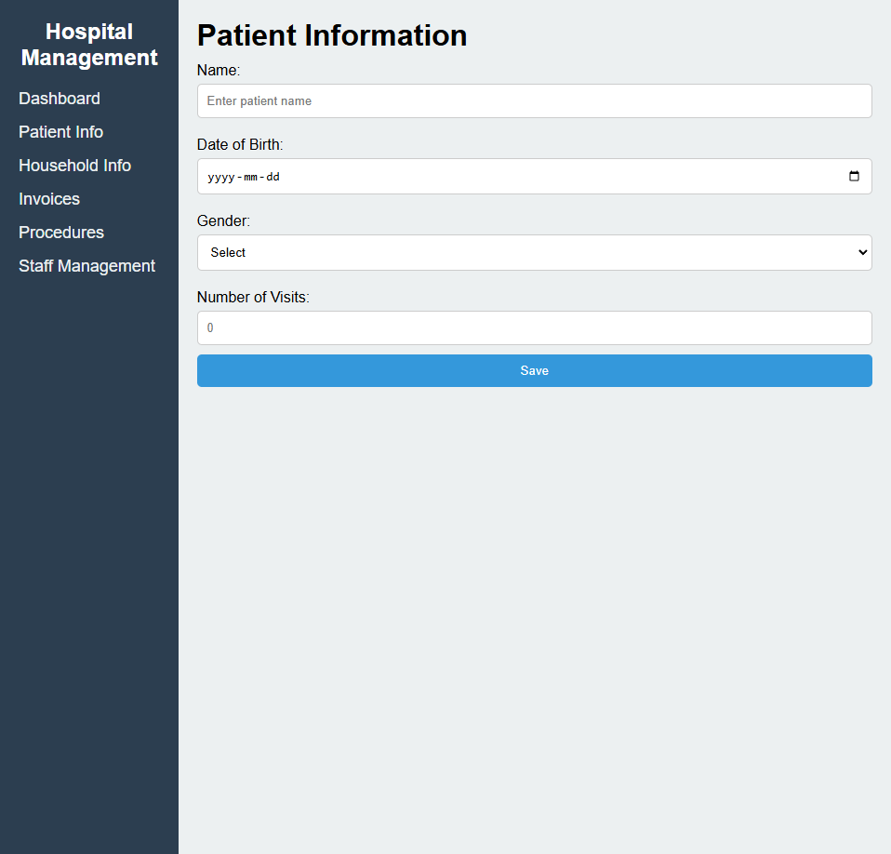
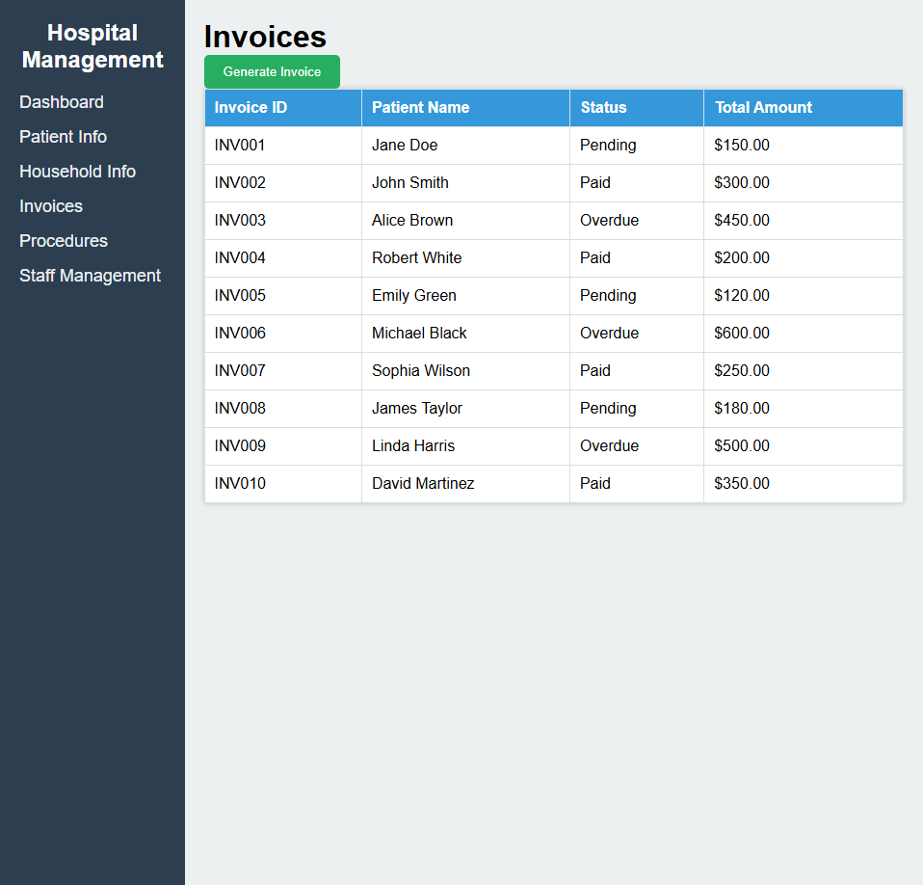
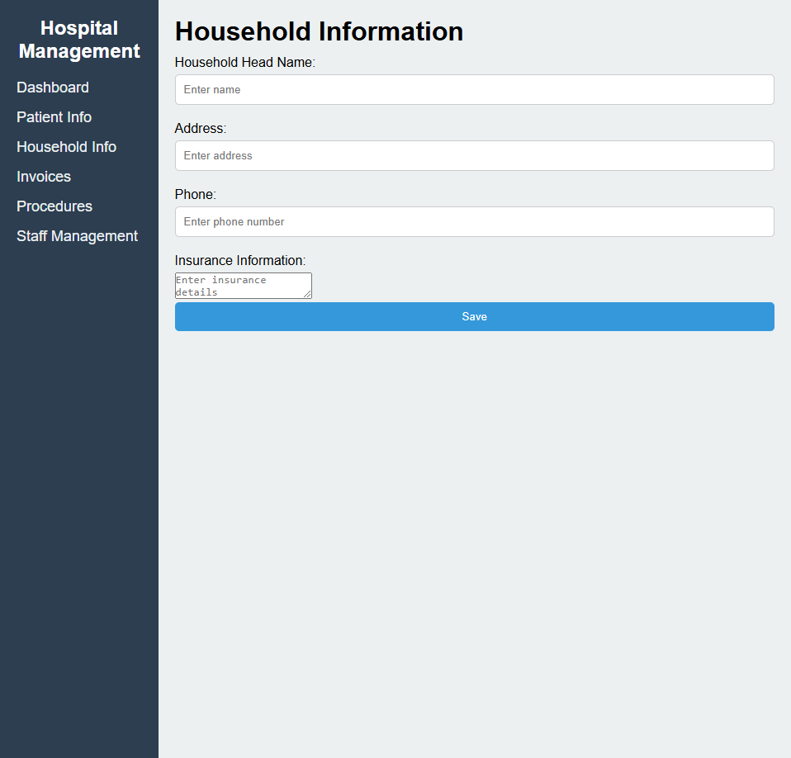

Conclusion:
The Hospital Management System is an effective solution to operations within this hospital. It manages and deals with patients, staff, invoices, and payments effectively. With these use cases and functional requirements, this solution promises an improvement in hospital procedures. This solution also improves operational efficiency and will reduce errors within the system.

References

Satzinger, J. W., Jackson, R. B., & Burd, S. D. (2016). Systems analysis and design in a changing
world (7th ed.). Cengage Learning.

